Magazine Summer 2017 

**“ WORSHIP. FRIENDSHIP, ACTION, - A KIRK THAT CARES “**

Welcome to the Summer Magazine 2017

As usual the magazine is being delivered early for summer. This is to coincide with the elder’s visit. We’ve had a few really summer like days recently but they have been well outnumbered by the cold and wet, let’s hope as we head to summer the nice sunny and warm days return it seems when the sun shines everybody smiles and feels much brighter and happier.

Westburn continues to be very busy with all our organisations and committees working hard and enjoying friendship and fellowship. Our buildings are also well used by many outside groups for meetings, coffee mornings etc which is good for the community and Westburn, this is helped by out three church officers Danny, Gillian and Duncan who help keep things running smoothly.

Cruise Ships – This year we again hope to welcome visits from the Cruise ships, and we will be looking for volunteers to help, more details will be in the Order of Service later.

Whither at home or on holiday have a great summer hopefully enjoying lovely weather.

Brian Lindsay from the Communications Committee produces the Magazine and appreciates your input helping to make the magazine interesting, please keep this up, Notification for material for the Autumn magazine will appear in the Order of Service.

Dear Friends,

One of the positives of living in a part of the country where we get more than our fair share of rain, is that we also get more than our fair share of rainbows. I am always amazed at their colour and beauty, whether a strong, bright rainbow, a fragile wispy rainbow or even a double arc rainbow. My friend Valerie gave me a lovely glass rainbow which means I can see a rainbow every day. The rainbow has symbol and meaning for us as we remember the story of God’s promise given to Noah.

Dr May Angelou (1928 – 2014) was a writer, poet, film director and civil rights activist. She spoke of people who had been rainbows to her in her clouds through their acts of kindness. She reflected on an old African American song which includes the words ‘ when it looked like the sun wasn’t gonna shine anymore, God put a rainbow in the clouds ‘ and she said “ It seems to me that you’ve got to prepare yourself so that you can be a rainbow in someone else’s cloud, someone who may not look like you, may not call God the same way you call God, if they call God at all, may not eat the same dishes, prepared the same way as you, may not dance your dances, speak your language. But you be a blessing “

So how many rainbows can we see in our congregation and community? Do we number among them?

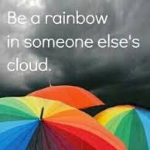

Yours

Karen

What a few weeks it has been! There have been lots of firsts, my first time as the celebrant at Holy Communion, my first Baptism, first Kirk Session and Stated Annual meeting, first time meeting the various groups and getting to know people as I meet them for the first time, first time in the local Primary school and at Easter, Inchinnan Parish Church will have had their first 7am Easter Sunrise Service. Life has been busy, but it has been wonderfully blessed. And with a wedding coming up there will be still more first to come.

The variety of my workload is incredible and I count myself fortunate to have had Karen as a supervisor for my probation as she gave me a good grounding and understanding of what life as a full time minister could be like, as well as a lot of good advice which I am trying to follow.

As a family we still have boxes to unpack, places to be found for pictures and other bits and pieces but we are settling in well – or at least I should say that the boys haven’t missed their train for school yet as getting up an hour earlier has been a bit of a shock for them! Molly has found places to walk and Alan has discovered the express bus to take him into his work in Glasgow stops right outside the Manse.

Everyone I have met have been very welcoming and friendly, Inchinnan feels like a rural village and I have even avoided getting lost in the maze that is Erskine when visiting the part of the parish that lies there. They folk here still talk of the night of the Induction and Ordination, and I must thank everyone who came along and made it a night of vibrant, meaningful worship – a night I will always remember. Thank you to those who gave cards and gifts although many got mixed up on the night and I am not sure who all I need to thank, so please accept my grateful thanks now for all your kindness.

I need to thank everyone in Westburn Parish Church for all the support over my time spent there, it really did feel like I was one of the family and I miss being there, but I keep Westburn folk in my prayers.

Blessings

Ann Knox (Rev)

**What has gone on in Westburn since the last Magazine?**

On Sunday 29th January we had a visit from the Very Rev Dr Russell Barr.

Looking back to his five years in Greenock, the building of the youth hall was one of the highlights, so too was the evening when we hosted the London Community Gospel Choir and the rafters of this historic church building shook as never before.

The theme of the service was **Vocation.** It was opened by our own minister Rev Karen Harbison who welcomed Russell and his wife Margaret to our Service with the reminder that he had been the first minister of the then newly formed St. Luke’s which moved on to become Westburn Church.

Although he once dreamed of winning the Open Championship and wearing a green Masters jacket, not for a second would he wish to change his life back again for his calling to ministry remains as strong now as it did then, and the work of ministry remains as varied and demanding as it is frustrating, challenging, enjoyable and rewarding.

Russell asked is there someone you would encourage to think about ministry, someone in whom you recognise a potential which perhaps they don’t recognise in themselves? Would you be interested in finding out more about the various ministries of the Church.

At the conclusion of the Service, most of the congregation moved to the main hall where a sandwich lunch had been prepared by the Fellowship Committee assisted by members who had contributed a vast array of sandwiches and cakes.

After an enjoyable lunch with much talk at the tables, Russell rose to address our gathering. Saying again how pleased he and  Margaret were to be back, it gave him particular pleasure to see Alex Chestnut once again. This was met with instant clapping showing our appreciation of Alex. Russell also thanked Karen and the congregation for the very warm welcome he and Margaret had received.

**On Thursday 9th February was the Ordination and Induction of Ann**

The Presbytery of Greenock & Paisley held a Service of Ordination & Induction at Inchinnan Church. The Service was taken by Rev Ann McCool, Moderator Rev Dr Peter McEnhill, Presbytery Clerk, Rev Robert Mc Farlane, Minister of Paisley: St Mark’s Oldhall and Rev Yvonne Smith, Minister of Bishopton.

In a church, packed with both friends and members of the congregation a very meaningful Service took place during which Ann was first Ordained and then later Inducted to her Charge. At the conclusion of the Service, a Tea was laid out in the church hall with ample provision for all.

This was followed by a short social event introduced by the recent Interim Moderator of Inchinnan, Rev. Maureen Leitch, There was several presentations to Ann, including a set of Robes and a Preaching Scarf.

There was a strong representation present from Westburn who had the opportunity to congratulate Ann and wish her well in her new charge.

**On the 15th February Local Heroes**

On the 15th February we had an evening of theatre, humour, music and storytelling celebrating HEROES and unsung HEROES in the bible, history and today.

Karen introduced Adrian and Bridget Plass who thanked Karen for the opportunity. They went on to tell some of the stories from the old and new testaments. Rob Halligan entertained with a selection of Songs and David Robinson entertained with sketches. After a break for refreshments we were entertained by the Hospice Singers.

Liz Smith of the Hospice Singers was interviewed by Adrian who praised the work of the Choir and how they are our Local Heroes. After more stories and songs the evening came to a close.

Our minister thanked Adrian and company for coming and entertaining us tonight.

**Annual Stated Meeting 2017**

The 2017 Annual Stated Meeting was held in the church after worship on Sunday 19th March. This was an opportunity for all members of the Westburn congregation to hear about what was going on in the church over the previous year, and in particular to receive the accounts.

At this year’s meeting, Craig Lindsay, the Convenor of the Stewardship and Finance Committee presented the accounts, which had already been approved by the Kirk Session and had been available for members before the meeting. He outlined the financial position for 2016 which showed a decrease in both income and expenditure. Income was down from £202,000 in 2015 to £166,000 in 2016. Income from hall lets was up and thanks were due to Gillian McAllister for administering our lets.

There was a deficit of £38,000 over the year, which was an increase from £8,000 in 2015, largely due to a fall in income from offerings. Craig showed us a graph of offerings in recent years and this showed a spike following the stewardship campaign in 2013. The budget for 2017 was for offerings to fall by a further £5,000, but a stewardship campaign was being planned.

Our investments increased in value over the year, but they could fall in value in future.

Jim Bell retired as Property Convenor at the end of 2016 and we had still to appoint a replacement. Members were asked to consider how they could help. Jim was thanked for all his hard work.

The main property work in 2016 was the replacement of windows in the tower. The Presbytery Quinquennial property report was received at the end of the year and was very favourable reflecting all the work carried out in the past.

Our new Session Clerks, Liz Irvine and Hazel Munro, took office during the last year. Hazel thanked Stuart Robertson and Alan Gallacher once again for their work over many years and for their support and help to her and Liz in their new roles.

The highlights of 2016 included the 10th anniversary service for Westburn Church when it was good to welcome back Rev Douglas Hamilton and Very Rev Bill Hewitt.

Ann Knox had thrown herself into the work of the church and it had been a joy to see her attain her new life and ministry in Inchinnan.

The “Christmas” Fayre had been held in September! This had involved all church organisations and some local charities. This was a great example of the church family working together.

Our minister, Karen Harbison, reminded us that we all have to use the gifts which God has given us and to share His love in the community we have been called to serve.

She said that the Local Church Review which had taken place during the year was an opportunity to look at past highlights, but was more future focussed on how to serve our members and community over the next five years. Areas highlighted included expanding pastoral care beyond those in nursing homes; more involvement in the wider community which we had already begun; developing work with young people through chaplaincy and the college; more involvement of members in worship; and how we can be more environmentally friendly. We had to take small steps to make progress and we could only do this if *everyone* is involved in the work and witness of the church.

Karen thanked everyone for attending and closed the meeting with the benediction.

NEWS FROM PRESBYTERY

Our former student assistant, Ann Knox, was ordained and inducted as minister of Inchinnan Parish Church on 9th February.

Rev Allan McIntyre, long serving minister of St Ninian’s, Larkfield, will retire in June.

Rev Jim Cowan (Barrhead St Andrew’s) has been nominated to serve as presbytery moderator from September 2017, to succeed Rev Ann McCool (Johnstone High).

Presbytery invites people to consider being trained as worship leaders. If interested, contact the minister.

Two Port Glasgow congregations, Hamilton Bardrainney and St Martin’s, have now been linked, and so will share a minister.

An account was given to Presbytery of the work of Prospects. This is an organisation which helps churches to welcome and accommodate members and visitors who may have some learning difficulties.

The World Mission Committee gave a report on Gender Based Violence (GBV), and efforts to counter it in some countries, such as Bangladesh and Zimbabwe, where it is prevalent. Presbytery encourages congregations to be aware of this problem and to pray for those who are affected by it.

The annual Pray Across Scotland service takes place on Tuesday, 16th May, at 7.30pm in Wellpark Midkirk, with Rev Alan Sorensen as guest speaker.

**7th Greenock Company, The Boys' Brigade**

As session 2016/17 draws to a close I can report that the boys in the company have enjoyed another year of fun, fellowship and some achievement. I have no outstanding news of Battalion honours gained or great team success in local or National competitions the only reason being we are operating with small numbers.

When the new session starts we will still endeavour to advance Christ's Kingdom among boys and will provide a safe and secure setting for boys and young men to pursue numerous activities giving access to fun, fellowship and adventure.

Therefore if anyone in the congregation can encourage boys of their acquaintance to come along on Friday evenings they will be most welcome. Obviously the more boys we have in the Company the greater the range of activities we can follow.

The new session will begin as always on the 1st Friday following the September weekend.

Anchor Boys and Junior Section

(Primary's 1 / 7 ) Friday from 6.00 until 7.20

Company Section

(Primary 7/Sec year 1 through to 18year olds) Friday 7.30 /10.00

I conclude this short note by assuring everyone that the officers and boys of the 7th Greenock Company will continue to further the work of the BB within the congregation "Sure and Steadfast "in the knowledge that this great organisation helps boys in their youth and can inspire them throughout their lives.

Company Captain

John Murray

**Scout Section Reports**

Beavers Section - The Beaver section has slowly increased in numbers and we now have ten. What we lack in numbers we make up for in enthusiasm. Hopefully this growth will continue.

Cubs Section - With the growth of numbers we have split the Beavers and Cubs back to two separate sections and to suit our current leadership shortage, Cubs now meet on a Thursday night. Although there should be five Cubs in attendance, since the new year it has been sporadic, but once they settle down to the new night this will, hopefully, stablise.

All in all we are a small group these days but leadership support is improving. As I write this we are starting a parent support group to encourage leadership and leadership support teams. Signs are already encouraging and I hope to be able to report new leaders by the next magazine.

Ricky Martin GSL

Scout Report September 2016 - April 2017

Scout numbers have increased to 13 from a low base of 2 and much of the increase can be put down to the high level of outdoor activities offered to the troop by the leadership team of 6 enthusiastic young leaders.

Since September scouts have participated in 3 outings to Glasgow Climbing Centre, attended 5 weekend camps, 3 at Everton Scout Camp, 1 at Fordell Firs and 1 at Lochearnhead Scout Station. Network, Explorers and Scouts have just completed walking the West Highland Way last week.

Six of the Network members have completed there Gold D.of E. and Queen Scout Award and I have been awarded the Silver Acorn. So far it has been a good year for the Scout,Explorer and Network sections of the Scout Group

Campbell Cairns

# Guild Report

By the time you read this the Guild year will have finished.

We started 2017 with a Hymnathon. This was followed by a Burns evening , where Mrs Ella Paterick entertained with some verses of poetry.

We had a craft night where Faye Gillies from Cardwell Garden Centre came along and showed some of the crafts she does and we were able to show what we could do with her guidance.

The second of our National Projects was Care for the Family “Let’s Stick together” a National Charity which aims to provide strong family relationships and help with those facing difficult situations.

Our A. B. M. was held in February with a Bring and Buy stall,the proceeds of which we had decided would go to Erskine. We also had a very interesting and thought provoking Bible Study from Karen on the theme for this year “Go in Joy”.

In March we had a very successful Fashion Show provided by Edinburgh Woollen Mill at Cardwell Garden Centre, where some of our ladies plus others from the congregation got to show off their style. A good night was had by all.

As a result of the Fashion show and also the “Bring & Buy “we were able to send a cheque to Erskine for £150.

We had a talk about C.H.A.S. from a local man Andy Kelly which was very informative and very moving.

Also in March we had a husband and wife team from Largs who spoke to us about the work of the R.N.L.I.

In April we had Aileen Macleod from Bishopton, this was a talk entitled “As a result of Fautering” (or footering) other Guilds have had her in the past and have entitled it “Oh Sew Tartan”. I prefer our interpretation. Basically she footers with pieces of tartan and makes little items, brooches etc.

We had a meeting which Karen led for Holy week.

Monday 17th. April was our last meeting of the session which was Presbyterial Council led with entertainment from Erskine Community Singers.

**Presbyterial Council**

We have had two meetings in 2017, one in February and one in April. February was in Old Gourock & Ashton and was the ABM. This was followed by Ivy Blair speaking on the National Project “All Friends Together “ (Prospects). All Friends together is about helping churches to welcome people with learning difficulties and including them in all aspects of worship. We decided that the last meeting in April would be more of an entertainment evening and indeed this is what it was , the entertainment being provided by the “Erskine Community Singers “ , this was not just about singing. It was a most enjoyable evening, missed by lots of people.

**Project Totals as of 5th. April 2017**

Ascension Trust (Street Pastors Scotland) £78,659.16

Care for the Family (Let’s Stick Together) £65,898.12

Caring for Mother Earth in Bolivia (C. Aid) £57,949.63

Feed the Minds (FGM in Kenya) £86,471.92

Mission International (Haiti Project) £53.037.35

Prospects (All Friends Together) £54,915.68

**Total £402.055.56**

**Cotlands**

Cotlands is a non-profit early childhood development organisation addressing the education and social crisis by establishing early learning playgroups and toy libraries in under-resourced communities to serve vulnerable children aged birth to six.

Founded in 1936, Cotlands was originally created as a sanctuary for abandoned babies. It all started one night when a baby was left on the doorstep of Matron Dorothy Reece's home in Mayfair, Johannesburg. She decided to take the infant in and care for it and so, Cotlands was born out of this single act of kindness.

Cotlands provides children with effective, high impact health, psychosocial and early learning play based development opportunities to help them thrive.

Cotlands has been a beacon of hope for thousands of vulnerable children since 1936. Now operating in 5 provinces – Gauteng, Kwazulu Natal, Eastern Cape, Western Cape and Mpumalanga – Cotlands reaches thousands more through its high impact early childhood development programme.

Children grow – and so have we. Today, Cotlands is a national non-profit organisation providing early learning playgroups, toy libraries, nutrition, health, psychosocial and residential child care in five provinces. Our brand and services continue to evolve to remain relevant to the communities we serve.

Currently operating in five provinces in South Africa, Cotlands provides a range of services to more than 8, 000 beneficiaries nationally.

Every financial contribution and service offering to our organisation makes it possible for us to continue providing for the vulnerable children in our country. With the assistance from our corporate donors, trusts, foundations, government, community groups and individuals, we are able to build a strong foundation of support for those who need it most.

# CELEBRATING 80 YEARS OF SERVING CHILDREN

On 1st August 2016, Cotlands turned 80 years old.  Following is a summary of the highlights of the last 80 years. Legend has it that, one night towards the end of winter in the lead up to WW2, Dorothy Reece, a nurse from the USA who had come to SA to do missionary work, found an abandoned baby on her doorstep.

She cared for the infant, and went on doing this work in a small way until the death of her husband made it impossible for her to continue to rely on her own resources.

The plight of unmarried mothers and unwanted and abandoned babies had become a passion with this remarkable woman; but in 1941 it seemed that her work in running her first Cotlands, as her home for babies was called, could continue no longer. Not only was there no more money, but she had incurred debts in the maintaining of the home.

The South Africa SUNDAY TIMES published her story. Within weeks thousands of rands had been collected and Cotlands was moved to a large house in Kenilworth.

**COTLANDS TRANSFORMATION**

Over the last few years, Cotlands, one of South Africa’s leading child care and development NGOs, has made the transition from being a residential-based care provider to a more community focused service, supported by residential care facilities.  Our objective is to intervene directly within communities to try and assist even before children need institutional care. We strongly believe that this is a more proactive, beneficial and financially viable approach to the social crises which confronts us.

Cotlands is a holistic community development organisation which actively finds solutions to real community problems. The Integrated Model of Care provides services to children and their families which ensure children’s protection (psychosocial), survival and nutrition (health) and development (education) through interventions such as providing ECD centres, active learning toy libraries, counselling, and food security amongst others. This process has not been easy, but complete transformation of our current programmes was required if we are to redefine child care and expand our services to reach a greater number of children. Bearing in mind Cotlands’ honourable and highly successful history of child care since 1936, we are conscious of ensuring our organisation remains relevant and is able to sustain its critically needed services to children for many years to come.  The South African Medical Research Council has recently estimated that the number of orphans in South Africa could rise to 5,7 million children by 2015.  Traditional child care models like residential care will not cope with this massive increase in the number of children needing care.

Two other factors were considered when the Cotlands board decided on their strategic shift. The cost of caring for a child in a residential care facility is approximately 10 times more than that of supporting the same child in their own community. The second factor that was a major influence in the organisation’s realignment is the negative impact of institutionalisation on children.

Studies show that children removed from their homes and their communities are more likely to experience serious developmental barriers. Compared to children raised in a family or community environment, they may struggle with everyday life skills and social interactions.  Even though institutional care is commonly used throughout South Africa and across the globe, recent research has shown that it is relatively ineffective in meeting children’s social, intellectual and emotional needs. The re-evaluation of Cotlands services has provided us with the opportunity to deliver exceptional models of care to children by empowering their families and communities with skills, knowledge, values and attitudes that will improve their quality of life.

Support for community based care has also been high on the agenda of national government. In 2002, government pledged to scale up family and community support mechanisms and scale down institutional care.  In so doing they are aligning with global trends and international bodies, including the World Health Organisation, in urging organisations that provide residential care to start moving towards more effective and holistic community based care.

In redefining its scope of services, Cotlands has taken these factors into account. This has helped shape the new Cotlands community care model. From July 2011 we no longer admitted any new children to the Gauteng and Western Cape hospices and sanctuaries and have made good progress towards finding alternative placements for our children currently in the residential programme. This has freed up time and resources to allow us to focus our energies into the more effective community based care models that we have implemented and are currently rolling out.

The Sunshine Association

The Sunshine Association is a dynamic, progressive and innovative non-profit organisation in the field of intellectual disability, offering diverse services at many levels. All developments and services offered by the organisation are a direct response to the needs identified in the communities.

The Sunshine Centre Association is committed to the development and inclusion of children with disabilities and delays – intellectual, developmental, and physical – in partnership with families and communities.

HISTORY

In 1976 a group of concerned mothers, headed by Sylivia Langenhoven, formed a small playgroup for their young children with disabilities. The aim of the group was to provide the children with early intervention and stimulation, and to support the parents.

|  |  |  |  |
| --- | --- | --- | --- |
| **Early Intervention Projects**  **• Early intervention day care programme  • Toy library  • Home-based support • Youth and siblings programme • Volunteer programme • Various training programmes • Early intervention day projects**  Our Early Intervention Projects are offered in Craighall, Eldorado Park, Soweto and Elsburg (Germiston).  These projects cater for children with intellectual, physical and developmental disabilities and delays aged 18 months to 7 years. |  |  |  |

There are two of the projects (Craighall and Soweto / Eldorado Park)

The sizes of the classes are kept down to a minimum with an average of 10 children per class to ensure individual attention.

Day care programmes run from 8:00 am until 1:00 pm with an Aftercare programme available at the Craighall and Elsburg centres. The Gauteng Department of Education school terms are followed. The children are supplied with two nutritious meals daily. School fees are determined by affordability of parents/families and a bursary facility is available should the family meet the required criteria.

All classes are managed by a practitioner with a minimum qualification of level 4 Early Childhood Development Qualification.

**Therapeutic.Services**  
Special Therapeutic assessments and regular input into the child's daily programme is provided by a Physiotherapist, Occupational Therapist, Speech Therapist and Social Worker.

Therapeutic seating and positioning aids maximise the impact of the programmes. Adapted equipment aids the development of independence in each child and is an integral part of the programme.

Thato’s Story

Thato Chauke is a 4-year-old boy with cerebral palsy who attends Sunshine Craighall Early Intervention Centre. When he joined in 2014 he was unable to do the simple things that most children his age could do. He could crawl but he needed to use his elbows, he couldn’t hold anything very well, and he found it difficult to feed himself and wash his hands. Thato also struggled to speak properly, which was made harder as English is a medium of instruction in the centres. His teacher used the recommended activities in our START programme to stimulate him, especially his arms. The activities encouraged him to straighten his posture and gradually he began using his palms, rather than crawling uncomfortably on his elbows. After some time, and as a result of these activities, Thato started crawling with both hands out straight. In class he was encouraged to start building blocks and basic 3 piece puzzles, to improve his fine motor skills. As these developed he began doing more things for himself and this boosted his confidence. Thato has shown the greatest improvement with his gross motor skills and we’re delighted that he is now walking. He is able to join in with the other kids during outdoor play, and he can walk up and down the stairs confidently using the handrail. He is a champion in Special Olympics and while he used to sit and hit the ball off the cone, he now

Update from Venda

We would like once again to thank our sponsors for supporting our vulnerable children, with no funding from the government over the past years, Vhutshilo Mountain School has continued to give best education and care to orphans and vulnerable children.

2017 marks twelve years of VMS and has been a great year for the children of our first class in 2005. These children are writing their matric (grade 12) this year in senior school. We have been informed that 88% of our former pupils have not had to repeat a grade, which is a wonderful achievement. This would not have been possible without the support of the Church of Scotland in Greenock and Gourock

The school has opened on the 18th April after the Easter Break.This year the pre school have 66 children.  These children are divided into 3 class groups, R grade with 22 kids, pre school with 24 and 20 babies. This year we have added R grade due to parents demand.

Most of the orphans and HIV+ children have sponsors from Scotland.  As we have well trained pre school teachers, and have a very good reputation in the community, local middle class families are prepared to pay for their children to attend the school.  This not only cross subsidises the non paying children but also plays a huge part in reducing stigma, as everyone knows that the school mainly caters for HIV+ children and orphans.

As you can see, Vhutshilo Mountain School continues to be a mainstay for the community in Venda.

As some of you know, Susi has had some health problems recently and she asks that you all remember her in your prayers.

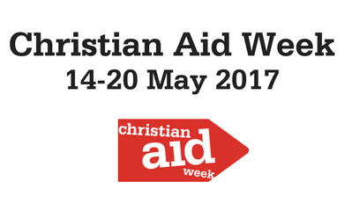

On Sundays 7th, 14th and 21st of May worshipers at Westburn Parish Church will be invited to contribute to the Greenock Christian Aid appeal for 2017.

**Christian Aid** is the official relief and development agency of 41 British and Irish churches, and works to support sustainable development, stop poverty, support civil society and provide disaster relief in South America, the Caribbean, the Middle East, Africa and Asia. Christian Aid campaigns to change the rules and systems that keep people poor, speaking out on issues such as tax justice, trade justice, climate change, and Third World debt. Christian Aid has fought poverty for more than 75 years.

Please give as generously as you are able and please remember to ‘Gift Aid’ your donation if you are a UK taxpayer.

For more information visit:

http://www.christianaid.org.uk/christian-aid-week

**Pastoral Care Committee**

1. The Committee met on 14th March 2017 and the next meeting will be on Tuesday, 9th May 2017.
2. **District 22 –** all members who are in nursing or care homes are regularly visited by the Committee. In addition, Karen, our Minister is also visiting Members in hospital and at home.
3. **Harvest Thanksgiving –** Sunday, 24th September 2017, when the Congregation will once again be invited to put a monetary gift in an envelope marked “South Africa” during the offering. There will be an opportunity to donate up to and including Communion on Sunday, 1st October 2017. The money will go to Venda, Cotlands and Sunshine Centre
4. **Annual Car Run,** followed by a light supper will be held on Wednesday 21st June 2017. If you would like to attend, please contact your District Elder.

Bill Dempster

**Fellowship Committee Report**

A great afternoon of fun and friendship was had by all attending our recent showing of Singing in the Rain followed by a delicious afternoon tea.

We hope to hold another film show in the autumn with another Golden Oldie Musical.

Our next event is our annual bowling night in June/July (date to be arranged). Bowling followed by a short quiz and a fish supper. No bowling experience required., This is a fun night. You don’t have to bowl, come and spectate and enjoy the fellowship.

Transport always available to all our events.

Linda Murray Convenor

**Used Stamp Appeal**

Evelyn Taylor writes

I am pleased to report that the amount raised for last year’s project for used stamps was £4334.00 – a great total for our World Mission Project. My sincere thanks to everyone who contributed.

The project for 2017 is for the Griffen Institute of Theology in South Sudan – established in 1974 and plays a vital role in education and equipping students for the ministry but has suffered as a result of violence over the past few years – relocated twice but has now been re-established in Kenya. Resourses have been lost, the library burnt to the ground. Money from this years stamp appeal will help to replace those resourses and buy books for their library. So I ask you to please continue to put your used stamps in the little red basket for this worthy cause.

My Sincere thanks to everyone once again for your support.

TIME FOR PRAYER

Like our church, the United Nations is an organisation which aims and strives to promote peace and harmony all over our world. Here is its prayer.

Lord, our earth is only one small star in the great universe. It is for all of us to make of it a planet whose creatures are not plagued by wars,

or suffer hunger and fear,

or torn apart in senseless division over race or skin colour or outlook.

Give us the courage and vision to undertake this task today: here and now,

so that in times to come all our children and children’s children will be proud to bear the name of humanity. Amen.

**Compassionate Communities**

A Compassionate Community is a community that provides support to someone who is experiencing a crisis, loss or is at the end of life. People in a Compassionate Community help care for each other through small acts of kindness and not think it’s the sole responsibility of health professionals.

Compassionate Inverclyde

In Inverclyde we are developing a public health approach to palliative care called Compassionate Inverclyde.

This exiting programme aims to

* Raise awareness about death, dying loss and care,
* Enlist communities in caring for their own family, friends, neighbours and strangers at the end of life at home or in hospital. (Compassionate Citizens/Volunteers).
* Improve wellbeing of individuals living in Inverclyde which can be transferable across any setting.
* Promote compassionate policies in local businesses.

The Compassionate Inverclyde programme will enable and empower people who are facing the challenges associated with the end of life to help and support each other at times of increased health need and in bereavement, recognising the importance of families and communities working alongside formal services.

Compassionate Inverclyde are happy also to work with churches for example, through bereavement café’s. This work is in its very early stages with the official launch having taken place on the 1st March this year.

For further information please speak to Karen

[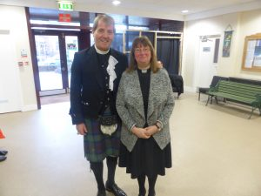](http://www.greenockwestburn.org.uk/rt-rev-dr-russell-barr-at-westburn/p1040526/)

Russell and Karen

[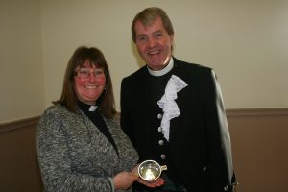](http://www.greenockwestburn.org.uk/rt-rev-dr-russell-barr-at-westburn/img_0037/)

Karen presented with Quaith

[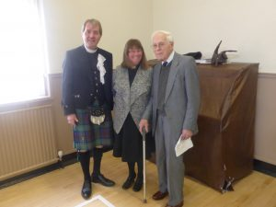](http://www.greenockwestburn.org.uk/rt-rev-dr-russell-barr-at-westburn/p1040557/)

Russell, Karen and Alec Chestnut

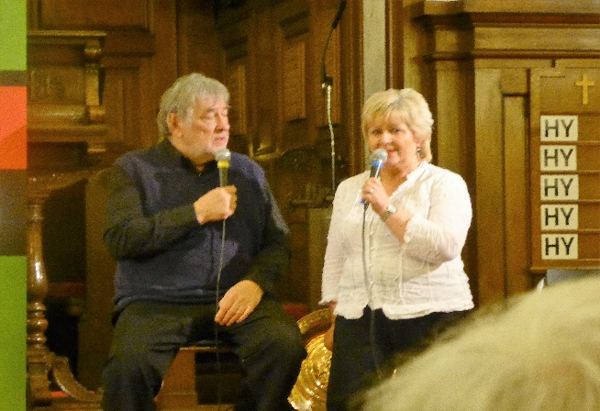

Liz Irvine with Adrian Plass

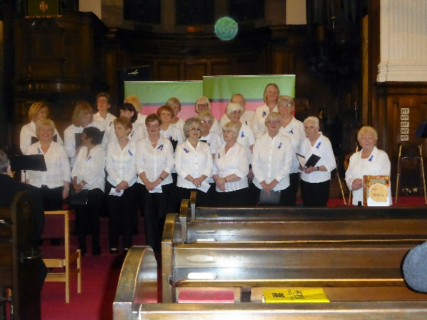

Hospice Singers

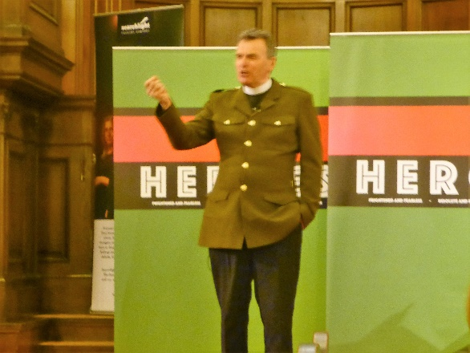

Thato from the Sunshine Association

[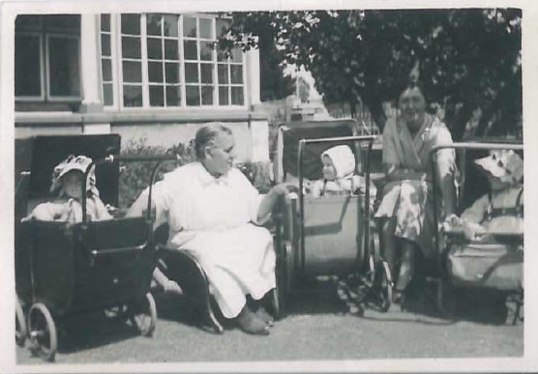](http://www.cotlands.org.za/wp-content/uploads/2016/07/babysanctuary.jpg)

Photo from Cotlands

From Venda

